## Fact sheet 1: Miro – Spear Thrower

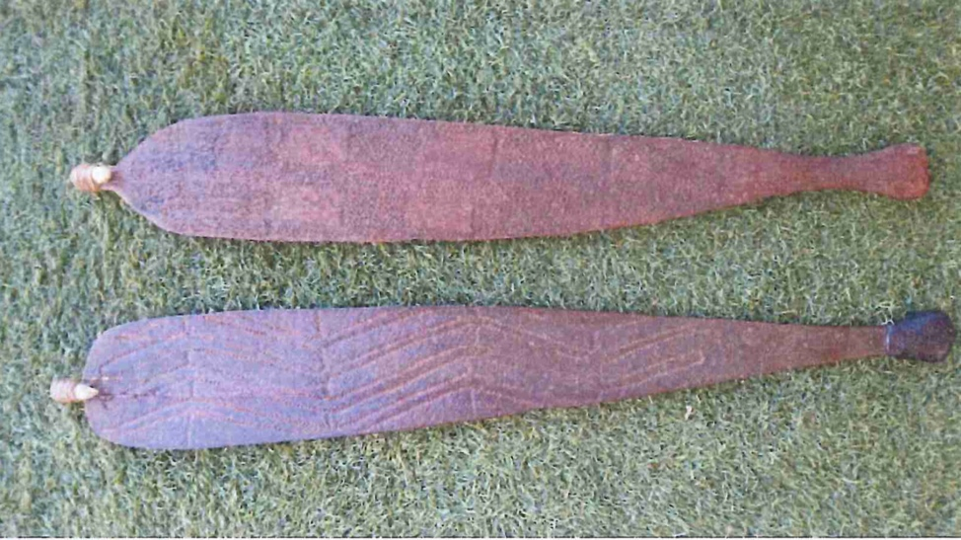Miro or spear throwers are a tool designed to increase the throwing distance or speed of a spear, often increasing the distance by 2-3 times. The length of the miro is made for the size of the thrower and works by doubling the length of the thrower’s arm. A barb or tooth is attached to the end of the miro to hook the spear into. The barb is attached by sinew, resin or string depending on the region. The handle is often given a rounded end made from resin.

The science behind miros is that of levers.. A lever is a simple machine comprised of a long rigid bar with a pivot point or fixed hinge known as a fulcrum. If you apply force in one direction on the bar, the fulcrum redirects the force in another direction. There are three types of levers.

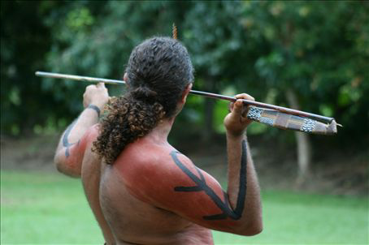

The process of throwing a spear involves a series of levers both within the throwers body, but also in the interaction of the tool and the thrower. **Not only does the use of a miro increase the distance you can throw a projectile, the use of levers also increases the velocity, acceleration and force of the projectile.**

This video show the Spear Thrower in action <https://www.youtube.com/watch?v=Llsi6o5ijLg>

## Fact sheet 2: Types of levers